**Abstract**

The ever-increasing cases of LPG gas leaks are a danger to safety in residential, commercial and industrial settings. This project suggests the IoT-based LPG Gas Leakage Detection that detects gas leaks and responds urgently in terms of safety. The system consists of a monitoring system using a MQ-2 gas sensor, Arduino Uno microcontroller board, servo motor, relay, buzzer and cooling fan to check the real time gas levels and react to them by switching off the supply of gas, sounding an alarm for ventilating the room. When the Arduino senses gas concentrations which are over the preset limit, it actuates the servo motor to shut the gas regulator and alerts nearby individuals with a buzzer.

The modularity of the system ensures minimal power consumption, it is affordable and it is reliable hence suitable for use in smart homes and gas-powered environment. Far from being simply a project that addresses the critical issue of gas leak detection, this project also shows how embedded systems and IoT technology can make safety better through the automation and real-time monitoring.

**Table of Contents**

1. Introduction 1

1.1 Current Scenario 1

1.2 Problem Statement and Project as a Solution 2

1.3 Aim and Objectives 2

1.3.1 Aim 2

1.3.2 Objectives 2

2. Background 3

2.1 System Overview 3

2.2 Design Diagram 3

2.2.1 Block Diagram 3

2.2.2 System Architecture 5

2.2.3 Circuit Diagram 5

2.2.4 Schematic diagram 7

2.2.5 Flowchart 7

2.3 Expected Outcomes and Deliverables 9

2.3.1 Expected Outcomes 9

2.3.2 Deliverables 9

2.4 Requirement Analysis 9

2.4.1 Hardware requirement 10

2.4.2 Software requirement 15

3 Development 16

3.2 Design and Planning 16

3.3 Resource Collection 16

3.4 System Development 17

3.4.4 Phase 1: Hardware Setup and Wiring 17

3.4.5 Phase 2: Sensor Calibration and Testing 19

3.4.6 Phase 3: Code Upload and System Integration 20

3.4.7 Phase 4: System Testing and Validation 21

3.5 Final Implementation 23

4 Testing 24

Test 1: Test if the sensor reads low and buzzer remains inactive in normal air 24

Test 2: Test if the sensor reads high and buzzer activates in presence of gas 25

Test 3: Test if the system reset after gas dissipates 26

Test 4: Test if system avoids false positives 27

Test 5: Test Servo Motor Operation 28

5 Future Works 30

5.1 Enhanced Gas Detection Technology 30

5.2 Improved Automation Tools 30

5.3 IoT Integration 30

5.4 Energy Efficiency and Backup 30

5.5 Safety Features 31

6 Conclusion **Error! Bookmark not defined.**

7 References **Error! Bookmark not defined.**

8. Appendix 32

8.1 Source code 32

8.1 Block Diagram **Error! Bookmark not defined.**

8.3 Individual Contribution **Error! Bookmark not defined.**

**Table of figures**

Figure 1: Block Diagram .................................................................................................. 3

Figure 2: System Architecture ......................................................................................... 5

Figure 3: Circuit Diagram ................................................................................................ 5

Figure 4: Schematic Diagram .......................................................................................... 7

Figure 5: Flowchart diagram ............................................................................................ 8

Figure 6: Servo motors (ElectronicWings, 2025) ........................................................... 10

Figure 7: Arduino Uno (Electronics, 2025) .................................................................... 10

Figure 8: LPG gas sensor (STEMpedia, 2025) ............................................................. 11

Figure 9: Buzzer (ELECTRONICS | PROJECTS | FOCUS, 2025) ................................ 12

Figure 10: Fan (Sonya, 2024) ....................................................................................... 12

Figure 11: Mini Breadboard (wikipedia, 2025) ............................................................... 13

Figure 12: Jumper wires (wikipedia, 2025) .................................................................... 13

Figure 13 Regulator (Rectory , n.d.) .............................................................................. 14

Figure 14 Arduino IDE (arduino, n.d.) ............................................................................ 15

Figure 15: MS Word (careerchangewales, 2018) .......................................................... 15

Figure 16: Hardware Setup part-1 ................................................................................. 18

Figure 17: Hardware Setup part-2 ................................................................................. 18

Figure 18: Hardware Setup part-3 ................................................................................. 19

Figure 19: Sensor testing .............................................................................................. 20

Figure 20: System Integration ....................................................................................... 21

Figure 21: System Implementation before testing ......................................................... 22

Figure 22: System after testing ..................................................................................... 22

Figure 23: Final Implementation .................................................................................... 23

Figure 24: Screenshot of Test1 ..................................................................................... 24

Figure 25: Screenshot of Test2 ..................................................................................... 25

Figure 26: Screenshot of Test3 ..................................................................................... 26

Figure 27: Screenshot of Test4 ..................................................................................... 27

Figure 28: Screenshot of servo before Test5 ................................................................ 28

Figure 29: Screenshot of servo after Test5 ................................................................... 29

**Table of tables**

Table 1: Table of Components and its Role .................................................................. 17

Table 2: Table of Test1 ................................................................................................. 24

Table 3: Table of Test2 ................................................................................................. 25

Table 4: Table of Test3 ................................................................................................. 26

Table 5: Table of Test4 ................................................................................................. 27 Table 6: Table of Test5 ................................................................................................. 28

# 1. Introduction

The Internet of Things (IoT) is an advanced era technology that enables smart automation and smooth-sailing connectivity to respond to a range of common complaints. IoT makes our living easier and more convenient through the use of sensors, actuators as well as microcontroller. This project aims at designing an LPG Gas Detection System whereby, gas leak is detected and rapid safety actions are taken to avoid accidents.

The main purpose of this system is to automatically detect LPG leaks and react on its detection, e.g. by switching off the gas regulator, thus eliminating fire, explosions etc. dangerous situations. The technology increases the safety of each person and the environment, as it uses the real-time monitoring and automation of control.

LPG accidents has become very high lately due to such concerns as broken pipelines, faulty connection and human error. By using manual detection, often responses are late and this may pose a risk. This given project addresses the problem by installing an intelligent automated system that can detect leaks and make preventive moves without human agency.

Not only does this project address issues with safety, but this project also demonstrates a smart solution to home automation. With the capabilities of the Arduino microcontroller and a gas sensor, the system allows for real-time monitoring of gas level and quick response with the help of visual, aural, and mechanical alarms. It shows coordination of embedded systems and IoT technologies in offering useful and life-saving solutions in the everyday environment.

## 1.1 Current Scenario

According to the data from the “Kirtipur Hospital shows that in the past three years a total of 134 people were admitted for treatment of gas explosion incidents, of whom 33 died in the hospital while undergoing treatment” (Ojha, 2025).

Furthermore, as per the records from Nepal Police Headquarters, in the last fiscal year, “five people were killed and 16 injured in LPG cylinder explosions. Similarly, in the fiscal year 2021-2022, three people were killed and 10 got injured in 10 cases of LPG gas explosions in the country” (Ojha, 2025).

This statistic shows the severity and recurring nature of LPG-related accidents, highlighting the need for a reliable solution i.e. LPG gas Detection System to prevent the potential hazards and improve safety.

## 1.2 Problem Statement and Project as a Solution

LPG gas is widely used all over Nepal in households and industries for cooking and heating purpose. However, in the time of leakage, there is a significant risk of serious hazards specially in the environments like industries, restaurants and households.

The LPG Gas Detection System is an automated safety solution designed to detect the presence of LPG gas in the surrounding and take immediate action. The system uses MQ-2 sensor to detect the concentration of LPG gas more than its threshold and sends the signal to server motor. The server motor shuts down the gas regulator to prevent the rise of accidents and improves safety.

## 1.3 Aim and Objectives

### 1.3.1 Aim

This project develops LPG gas detection system aiming to prevent potential hazards caused due to gas leakage which led to numerous fatalities. The system uses the combination of sensors, actuators, breadboard and other components to detect the gas leakage and activate safety measures in real-time.

### 1.3.2 Objectives

* Developing an automated LPG Gas Detection System
* Enhancing Safety measures and reducing risk of fatalities
* Addressing the leakage and turning off the gas regulator
* Implementing real-time detection and response

# 2. Background

## 2.1 System Overview

The LPG Gas Leakage Detection and Prevention System operates through an MQ2 sensor that detects gas leaks by measuring changes in resistance signal voltage levels for the Arduino processor. When voltage readings pass the designated threshold on an Arduino device it activates both the alerting buzzer and the action of turning off the gas regulator through a servo motor. The system allows for quick detection and immediate warning and it automatically shuts off the gas supply to avoid accidents.

## 2.2 Design Diagram

### 2.2.1 Block Diagram

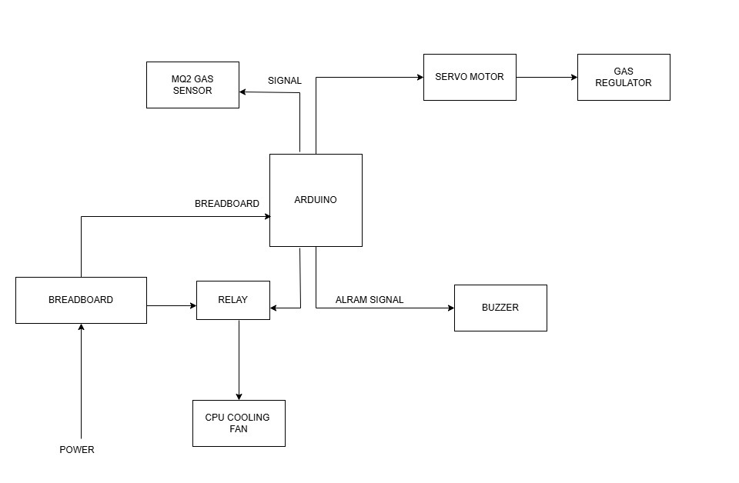

*Figure 1: Block Diagram*

This diagram outlines how the components of the IOT-based Automatic Gas Detection system work together.

**a. MQ2 Gas Sensor:**

This sensor detects the presence of gases like LPG, propane, methane, and smoke. When gas concentrations exceed a predetermined threshold, it sends a signal to the Arduino, allowing safety measures to be activated.

#### b. Arduino Microcontroller

* Serves as the main control centre that gets information from the gas sensor.
* Processes the sensor signal and makes decisions based on the gas concentration.
* Sends a control signal to the servo motor to regulate or shut off the gas flow.
* In order to notify users in the event of a gas leak, riggers have an alarm signal that sets off a buzzer.

#### c. Servo Motor and Gas Regulator

* To turn the gas regulator on or off, the Arduino controls the servo motor.
* This ensures automatic shutdown of the gas supply during dangerous gas levels, preventing accidents.

#### d. Alarm/Buzzer Module

* Receives an alarm signal from the Arduino.
* Sounds an alert to warn people in the vicinity of gas leakage, enhancing safety.

#### e. Relay and Breadboard

* Relay provides the required voltage and current to cooling fan
* The breadboard serves as a platform for prototyping that effectively connects components and delivers electricity.

### 2.2.2 System Architecture

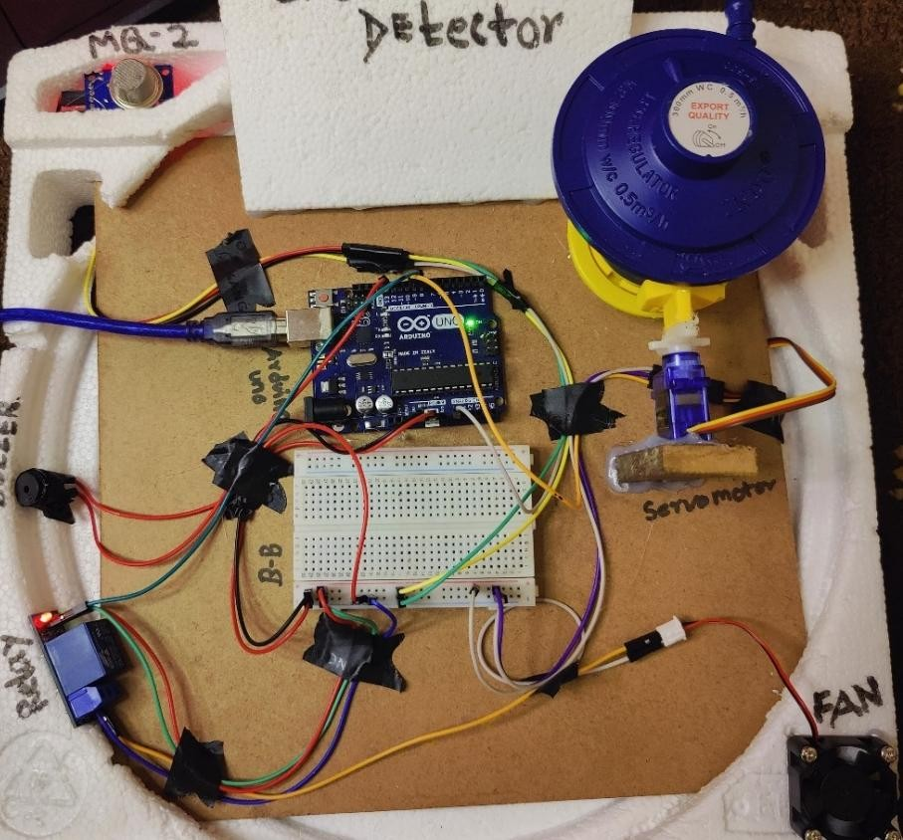

*Figure 2: System Architecture*

### 2.2.3 Circuit Diagram

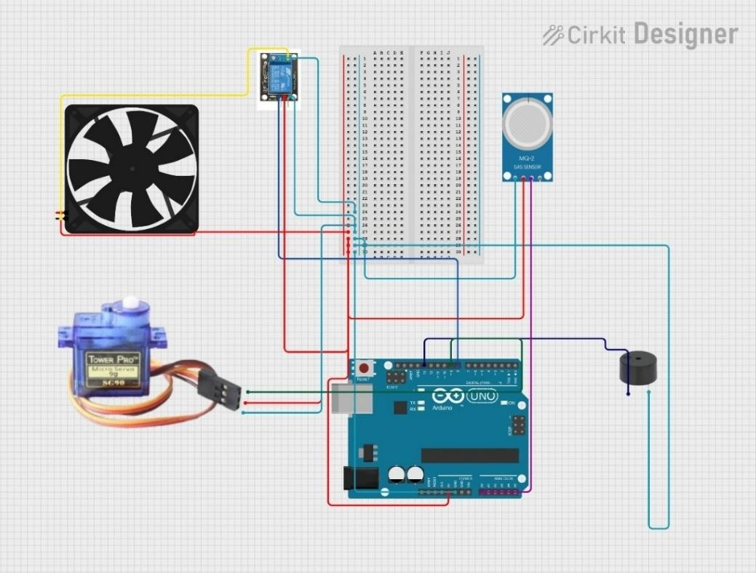

*Figure 3: Circuit Diagram*

The main microcontroller, is the Arduino UNO that communicates with input and output devices, making the circuit function.

* Gas Sensor (MQ-2 Sensor): Analog gas sensor detects gas concentration like smoke, LPG or CO. The analog output pin is connected to the Arduino’s analog input (A0). It monitors gas levels and it senses any gas that should not be there.
* Servo Motor: The servo motor (SG90) is connected to a digital PWM pin of the Arduino. When gas is detected above a threshold, the Arduino controls the servo to rotate. This can be used to trigger a physical mechanism
* Buzzer: The Arduino’s digital pin is connected to a piezo buzzer. It activates if it detects gas and supplies an audible alarm to the user’s senses to warn him of danger.
* Relay: Regulates high voltage from electricity to the fan using a low voltage being from the Arduino. It also isolates and protects the Arduino from the electrical dangers.

This setup is for time real time gas detection and gas safety response using Arduino UNO with mechanical and sound response on gas presence.

### 2.2.4 Schematic diagram

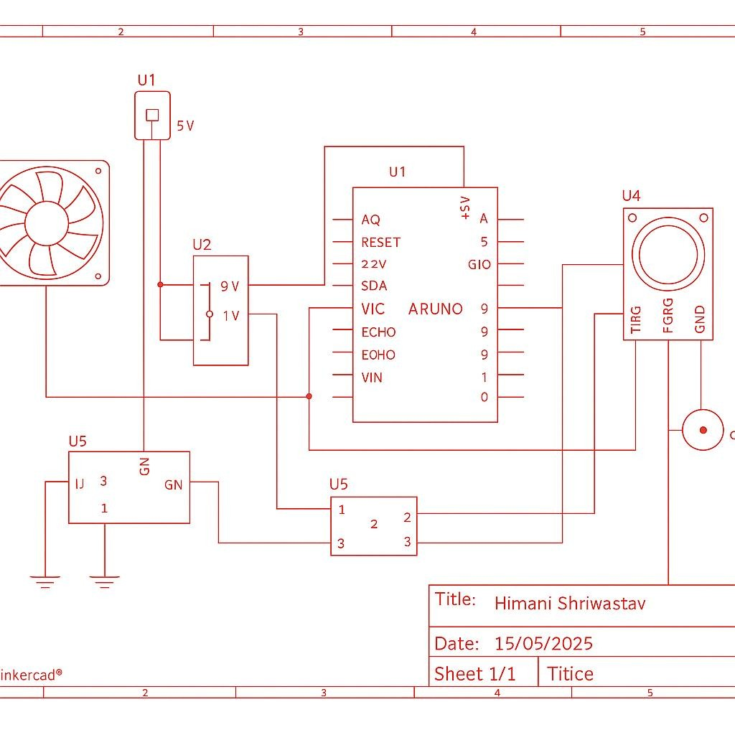

*Figure 4: Schematic Diagram*

### 2.2.5 Flowchart

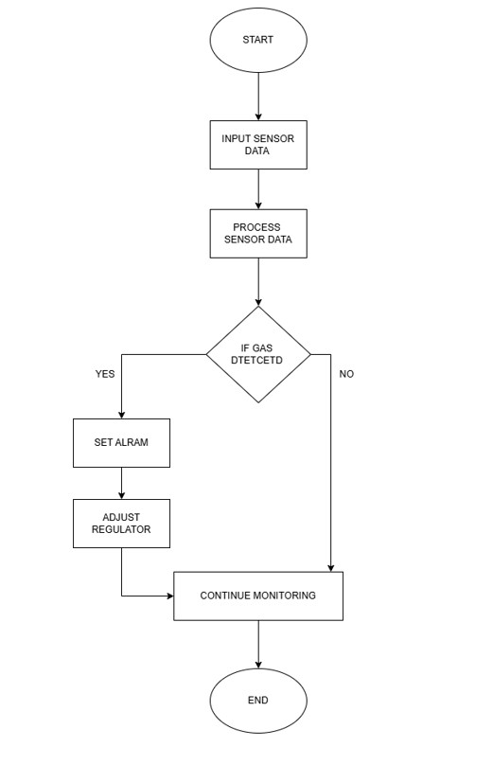

*Figure 5: Flowchart diagram*

#### Logic Flow

**Start:** It starts the sensors and the user input monitoring.

**Input Sensor Data:** Data from the sensor is collected

**Process Sensor Data:** The collected data is analysed to detect Gas

**Decision** - Gas Detected:

* **Yes:** The warning will sound and the regulator will automatically adjust if gas is detected.
* **No:** If gas isn’t detected then the system continues monitoring.

**End:** The process completes the cycle.

## 2.3 Expected Outcomes and Deliverables

The final project will be a working LPG gas detection system. This system provides an effective dependable solution to detect hazardous gas leaks in home, business and industrial facilities.

### 2.3.1 Expected Outcomes

* Detection of gas leaks: Gas sensors will enable the system to find LPG gas at low concentration. MQ2 gas sensor is used to detect the gas leaks.
* Real time Alerts: When the device detects gas presence it will buzzer alarm.
* Improvement of Safety: The device provides home safety along with restaurants and industrial safety through it automatic warning system that help to reduces fires and minimize the risks.
* Low power consumption: The System requires minimal power consumption for effective operation which help in continuous monitoring.

### 2.3.2 Deliverables

The final outcome of this project is the LPG gas detection system that detects leaks while keeping the safety measures. The core microcontroller of the system will be an Arduino Uno that pairs with an LPG gas sensor which will monitor the gas. Relay regulates high voltage from electricity to the fan using a low voltage being from the Arduino. A detection system will activate a buzzer and control the LPG regulator through servo motors to stop more gas leaks.

## 2.4 Requirement Analysis

The LPG Gas Detection System enhances safety operations through its automatic detection and reaction processes to gas leaks. The system regulates LPG gas levels using an LPG sensor where the Arduino Uno controls the servo motor usage for regulator shutdown together with notification buzzer functions. System functionality depends on further hardware components that consist of a fan along with a Relay and jumper wires. Users program the system through the Arduino IDE so that it can detect gas leaks in real-time.

### 2.4.1 Hardware requirement

* Servo Motors

Use: It will automatically adjust the LPG regulator knob to its off position in case of leakage.

Active: The device turns the mechanical regulator when supplied with power and control from the controller.

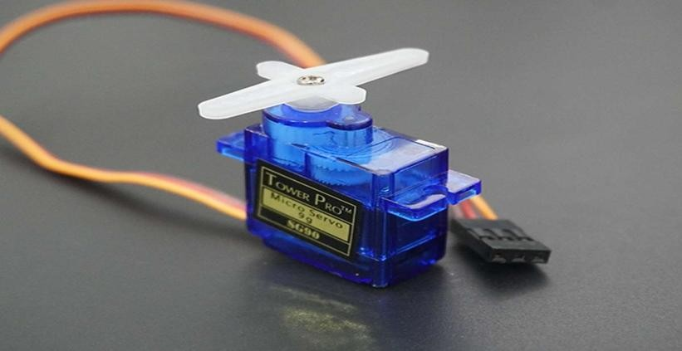

*Figure 6: Servo motors (ElectronicWings, 2025)*

* Arduino Uno

Use: It works as a microcontroller board that both responds to a gas sensors and controls output actions of fan buzzer and servo components.

Active: An active control unit needs power to process inputs and regulate outputs.

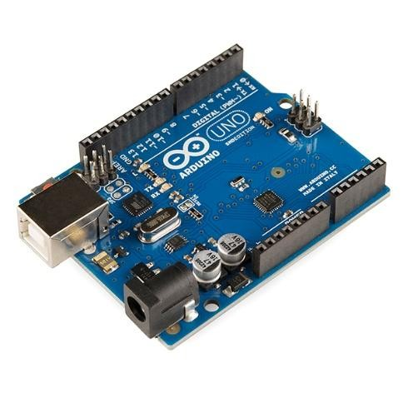

*Figure 7: Arduino Uno (Electronics, 2025)*

* LPG gas sensor (MQ2)

Use: It detects the presence of LPG gas in the surrounding air. When gas levels rise it sends a signal to the Arduino.

Active: This control system requires power to function while monitoring gas presence through its output delivery signals.

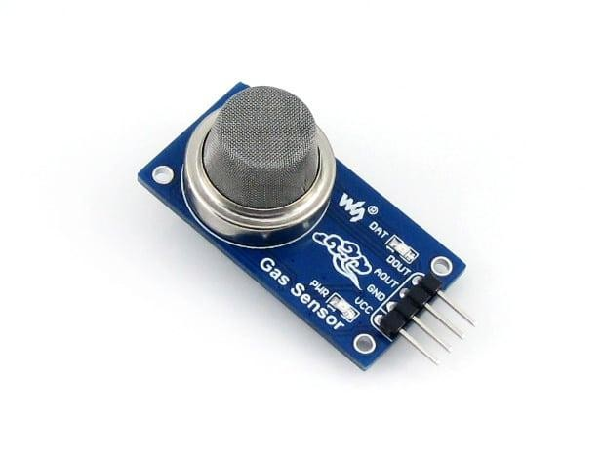

*Figure 8: LPG gas sensor (STEMpedia, 2025)*

* Buzzer

When the gas leak is detected, it will notifies by a loud alert sound signals.

Active: it uses electricity to produce sound.

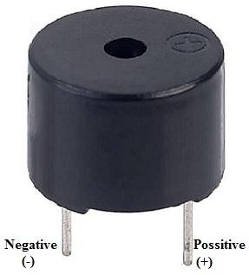

*Figure 9: Buzzer (ELECTRONICS | PROJECTS | FOCUS, 2025)*

* CPU Cooling Fan

It helps in gas distribution along with open airflow to maintain consistent and reliable measurements by the sensors.

Active: it needs power to rotate and helps in moving air around.

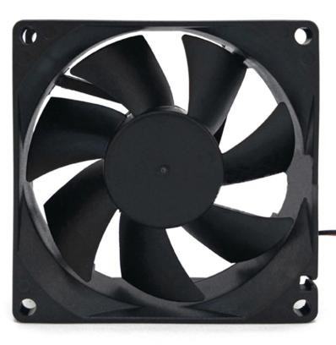

*Figure 10: Fan (Sonya, 2024)*

* Mini Breadboard

It is used for circuit prototyping and easy component attachments without soldering requirements.

Passive: The breadboard operates as an electrical conductive platform without using electrical power.

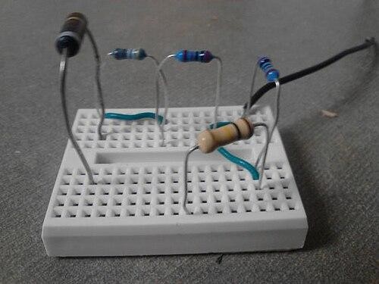

*Figure 11: Mini Breadboard (wikipedia, 2025)*

* Jumper Wires

It is used to assemble the circuit.

Passive: These wires don't operate actively as they carry electricity alongside signals.

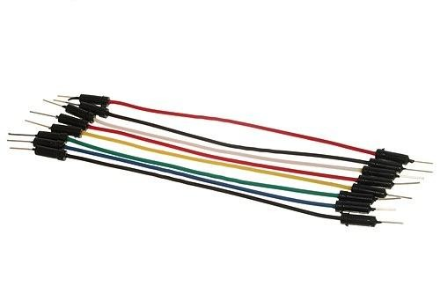

*Figure 12: Jumper wires (wikipedia, 2025)*

* LPG Regulator

A component operated by the servo motor regulates the gas cylinder to cut off the supply when a leak is detected.

Passive: Gas flow is controlled mechanically.

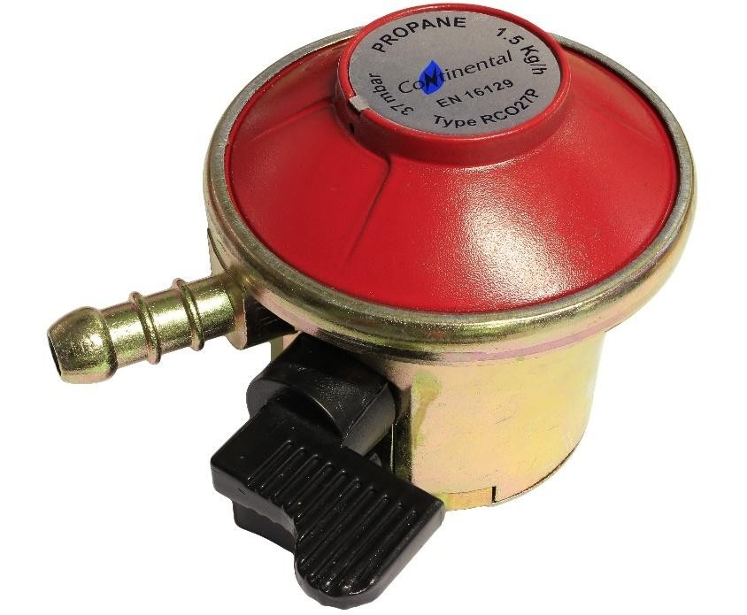

*Figure 13 Regulator (Rectory , n.d.)*

* Relay

The relay safely switches the high-voltage current to the fan on and off using a low-voltage signal from the Arduino. It isolates the Arduino from the dangerous high-voltage circuit, preventing potential damage or electrical hazards.

### 2.4.2 Software requirement

#### • Arduino IDE

It is used to write, upload and debug Arduino code that manages the program controlling elements, Sensors and decisions.



*Figure 14 Arduino IDE (arduino, n.d.)*

#### • MS Word

Microsoft Word serves as a popular word processing program which delivers flexible capabilities to both generate and edit and format documents.**Invalid source specified.**



*Figure 15: MS Word (careerchangewales, 2018)*

# 3 Development

## 3.2 Design and Planning

The purpose of this venture involved building a gas leakage detection system together with prevention capabilities using an MQ2 sensor. The initial step of design involved studying how the MQ2 sensor operates through detecting chemical substances including LPG, propane and methane gas. LPG detection output changes the sensor resistance and generates a variable voltage that an Arduino Uno microcontroller can interpret.

The designed system operated through this sequence:

* Continuously monitor gas concentration

The system will initiate the safety response when gas concentration reaches or surpasses the established safety threshold.

* Trigger a buzzer to immediately alert nearby individuals.

The servo motor turns due to operating the gas regulator to mimic gas supply shutdown.

Hardware design and system logic development along with gas leakage simulation took place during the planning phase. Quality performance in terms of accuracy along with responsive operation and safe conditions served as primary considerations. Future upgrades became simpler because the system architecture adopted modularity which allowed for readiness to work with IoT platforms

## 3.3 Resource Collection

All necessary hardware components were listed, sourced, and tested individually. The list includes:

|  |  |
| --- | --- |
| **Components** | **Role in System** |
| MQ2 Gas Sensor | Senses LPG; resistance changes with gas level |
| Arduino Uno | Reads sensor values, controls buzzer and servo |
| Servo Motor | Simulates gas valve shutoff mechanism |
| Buzzer Module | Provides immediate audio alert |
| Jumper Wires | Connections between modules |
| Breadboard | Prototyping and component attachment without soldering |
| Relay | Safely controls high-voltage power to the fan using a low-voltage signal from the Arduino. |

*Table 1: Table of Components and its Role*

**Software tools:**

The programming process along with serial monitoring functions through Arduino IDE. • Tinker cad Circuits for initial simulation and logic testing.

Both function testing and compatibility checks were completed to verify that every component worked properly within the complete system design.

The MQ2 sensor generates output through an analog signal that detects combustible gas concentrations in the atmosphere.

## 3.4 System Development

### 3.4.4 Phase 1: Hardware Setup and Wiring

During this stage, all the components are connected to Arduino Uno via breadboard. MQ2 gas sensor is set to detect gas leaks, a relay is connected with a fan to operate and a buzzer for sound alerts, a servo motor is used to simulate the act of switching off the gas regulator.

The components are nicely wired to the appropriate Arduino pins for adequate voltage and signal flow. Connections for power supply are protected to avoid voltage drops and instability. The breadboard layout has been made in order to avoid short circuits and loose connections. This step ensures that all elements are connected properly, energized and are ready for functional testing for the later phases.

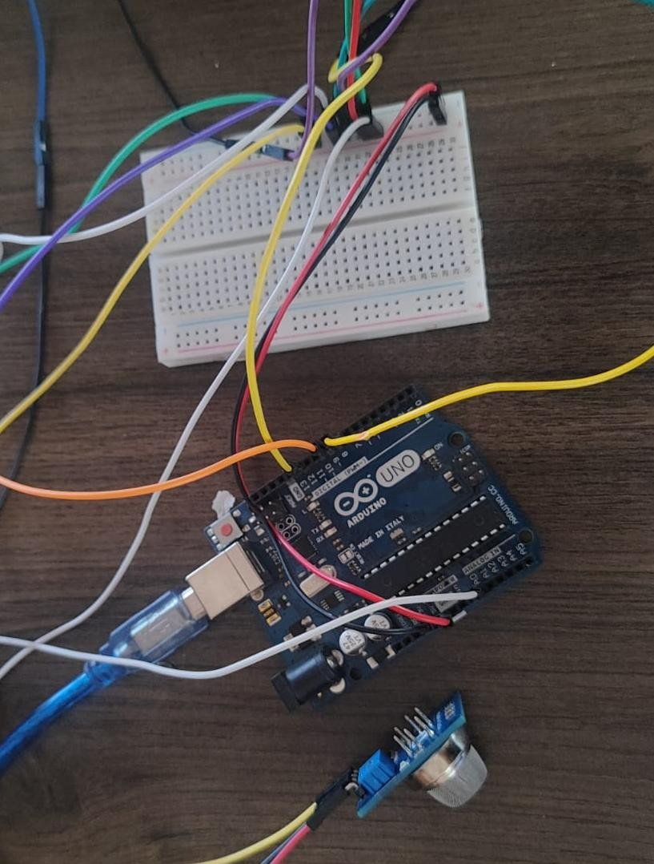

*Figure 16: Hardware Setup part-1*

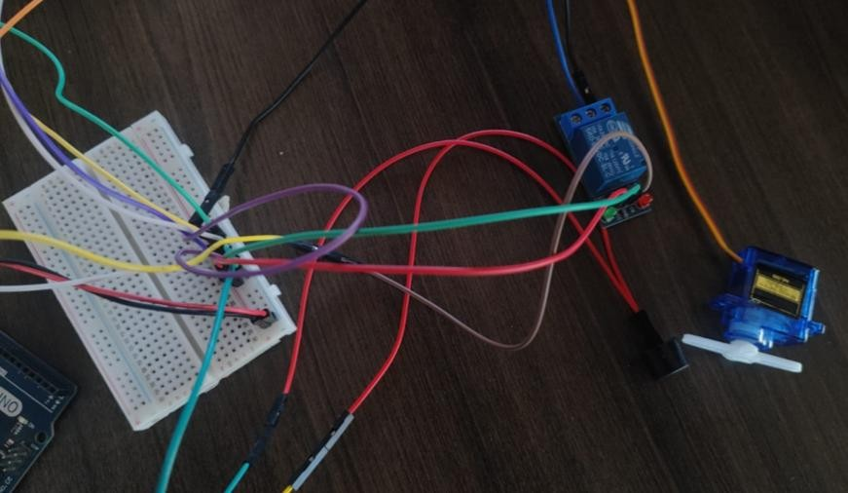

*Figure 17: Hardware Setup part-2*

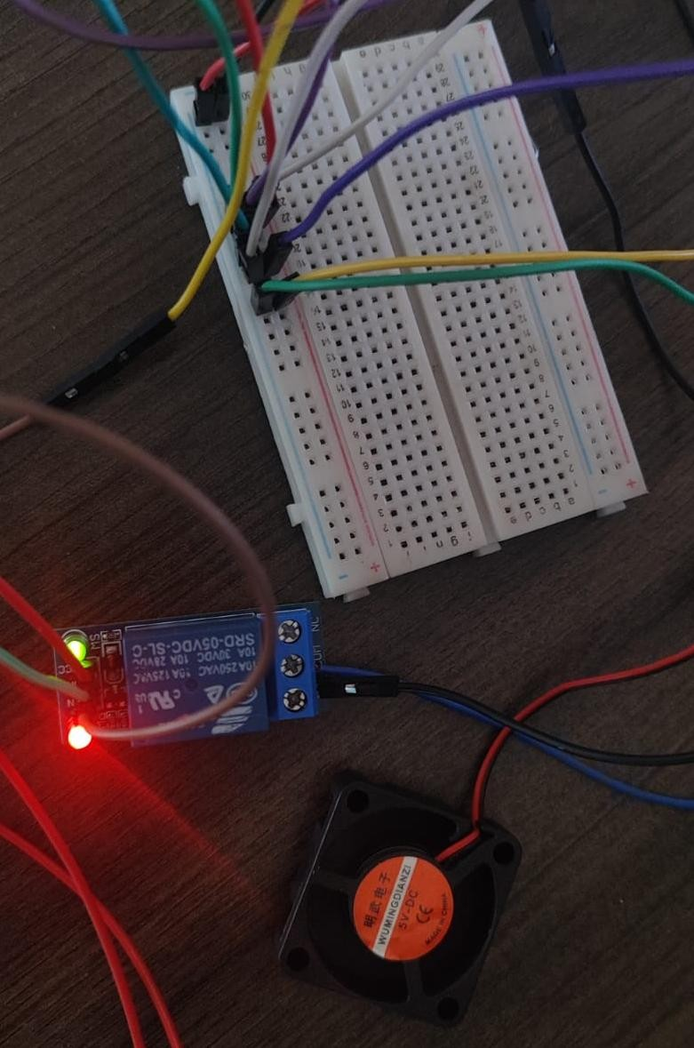

*Figure 18: Hardware Setup part-3*

### 3.4.5 Phase 2: Sensor Calibration and Testing

This stage is aimed at finding the response of the MQ2 gas sensor to LPG. Just small quantity of gas is emitted near the sensor, and the readings are displayed right in the serial monitor of Arduino. In case if the sensor reacts too fast or too slow then the code is changed accordingly to make the changes.

The idea is to set a level at which gas levels can be measured in such a way that only honest breaches are detected and other false alarms are eliminated. The method is used several times to make sure that the results are credible and consistent. Safe testing is promoted by the application of proper ventilation to prevent sensor overloads.

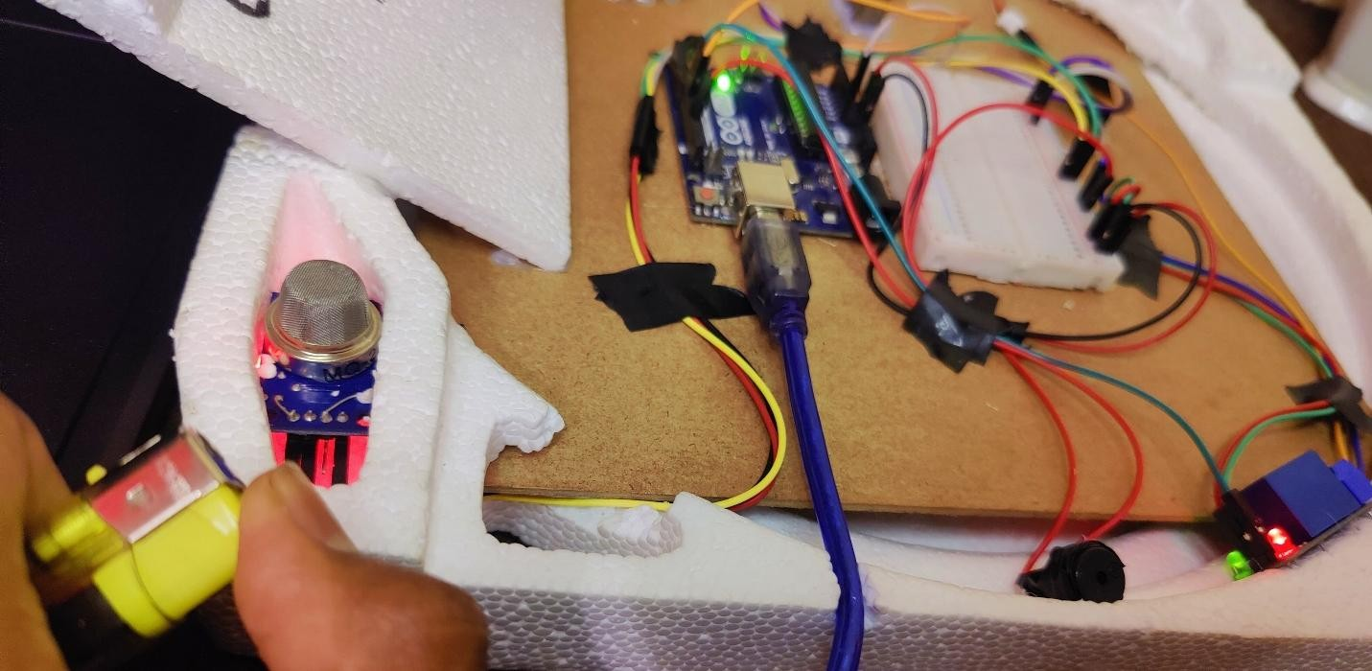

*Figure 19: Sensor testing*

### 3.4.6 Phase 3: Code Upload and System Integration.

In this phase, an Arduino is filled up with the program, which controls the whole system’s behavior as a gas leak occurs. The program reads the MQ2 sensor and notifies on exceeding a predetermined level of gas. When it happens, the buzzer rings an alarm, the relay turns on the fan for ventilation and the servo motor turns mimicking how one turns down a gas regulator.

All parts function according to the programmed logic and an integrated and automated safety system is achieved. Each answer is timed and it automatically acts quickly to minimize potential damage.

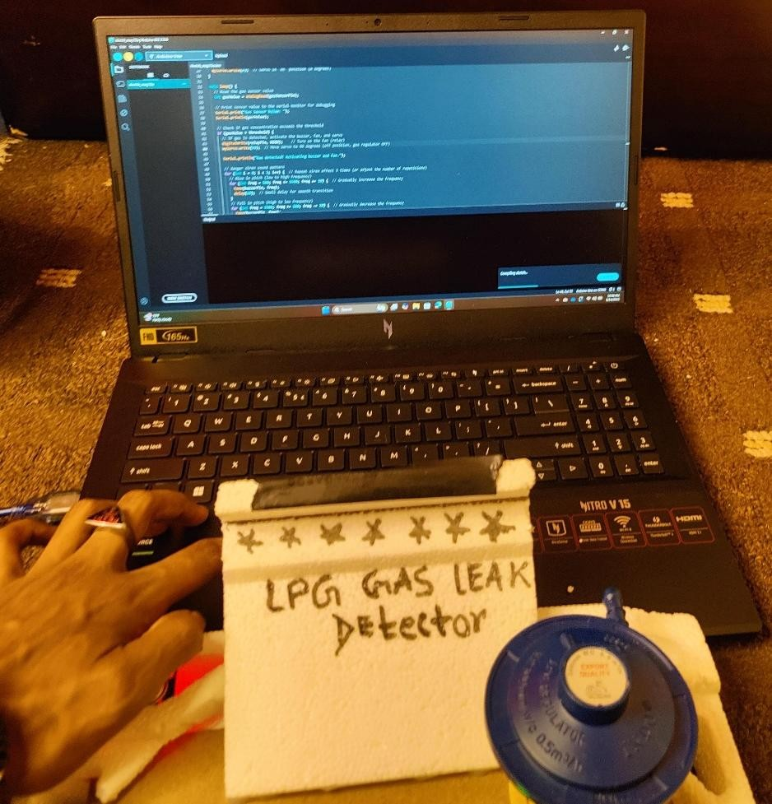

*Figure 20: System Integration*

### 3.4.7 Phase 4: System Testing and Validation

In the final stage, a certain quantity of gas is decom-pressed close to the sensor to examine how the system responds. When the gas level exceeds the threshold, the alarm reminds, the fan switches on to ventilate the gas and the servo motor rotates to lock the gas regulator. If all the parts work as predicted, the system is fully functional and can be deployed for the real-world application.

A number of test cases are exercised to assure that the system is responsive regardless of the events and the conditions. Additionally, the dependent is measured in determining the time that the system takes when it responds to gas detection and if it can reset and operate successfully after each test. This should ensure that the technology is ready to be used in a real-world safety scenario.

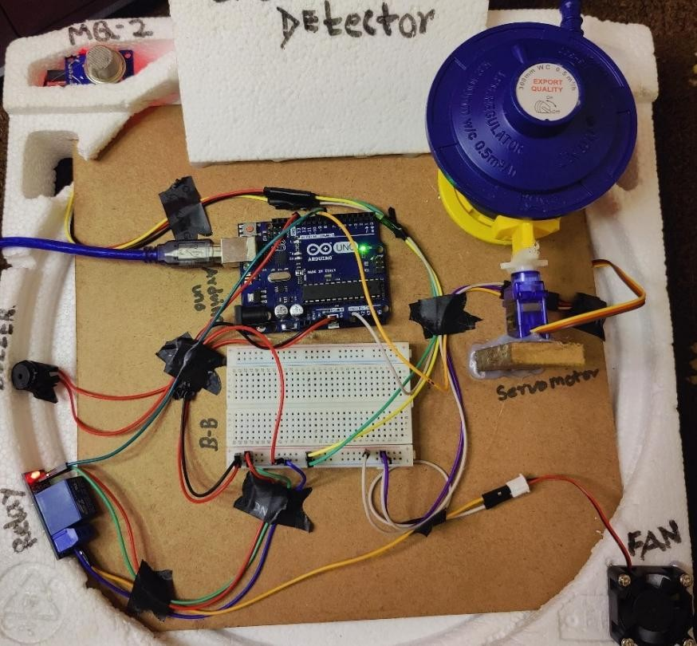

*Figure 21: System Implementation before testing*

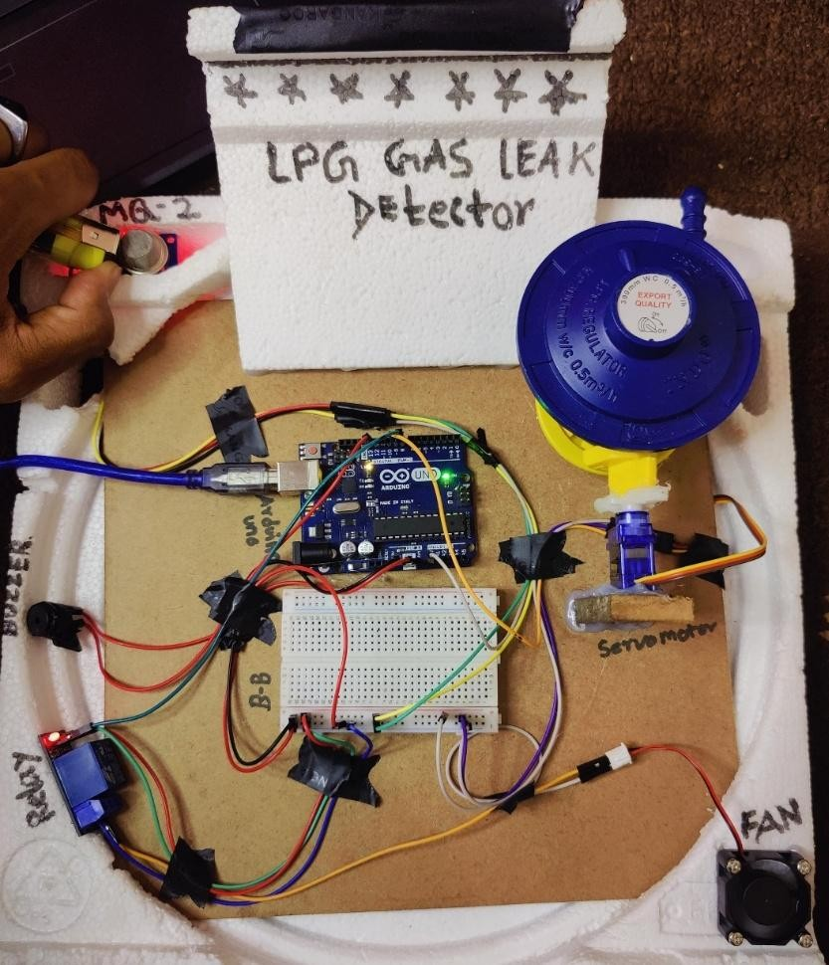

*Figure 22: System after testing*

## 3.5 Final Implementation

The ultimate prototype demonstrated portable design features with fast response time and reliability characteristics. The device conducts continuous environmental monitoring for LPG gas leaks before making immediate responses through both safety alerts and the termination of gas supply. The servo actuation demonstrated consistent reliable performance while delaying operation at a minimal rate and the buzzer emitted appropriate volumes for alerting people in a space of room dimensions. The developed system offers an affordable safety-critical solution which can be applied in smart kitchens and gas-based appliances and industrial applications. The future development will incorporate an IoT module like ESP8266 for SMS notification and mobile dashboard leak monitoring capabilities.

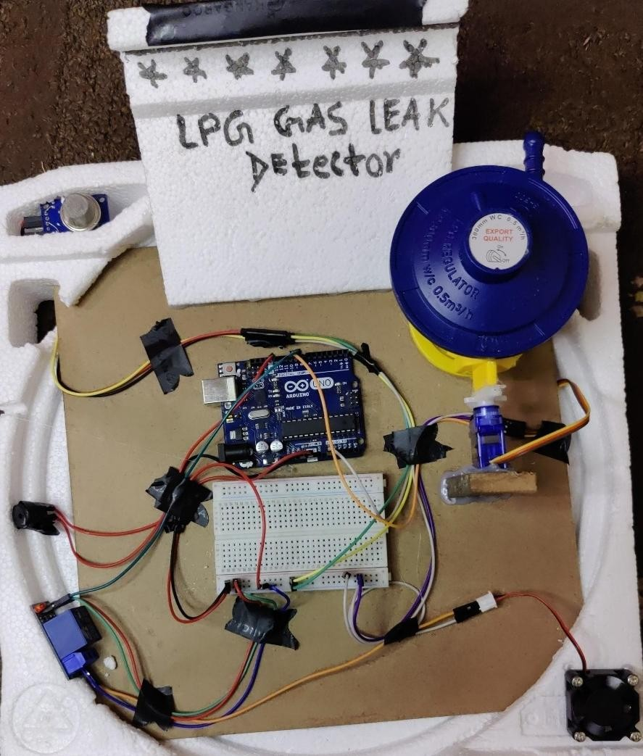

*Figure 23: Final Implementation*

# 4 Testing

## Test 1: Test if the sensor reads low and buzzer remains inactive in normal air

|  |  |
| --- | --- |
| Objectives | To verify that the system inactive under normal air |
| Activity | The system should be powered in the clean air without the presence of any gas and observe the sensor reading, buzzer and servo |
| Expected Result | Sensor’s reading must be low and buzzer remains off |
| Actual Result | Sensor value remained below threshold and buzzer stayed off and servo did not move |
| Conclusion | The test is successful. |

*Table 2: Table of Test1*

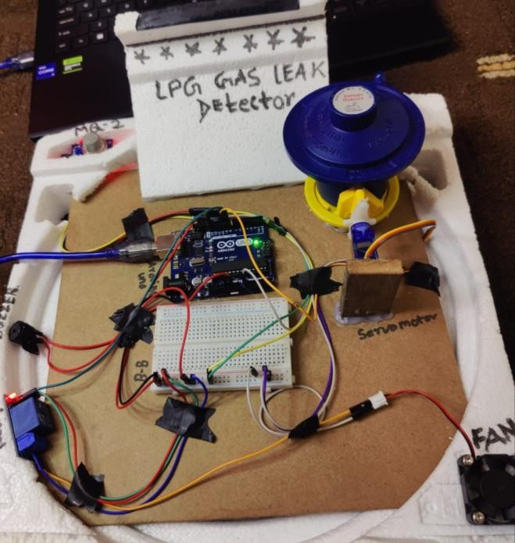

*Figure 24: Screenshot of Test1*

## Test 2: Test if the sensor reads high and buzzer activates in presence of gas

|  |  |
| --- | --- |
| Objectives | To verify that the sensor detects LPG gas and triggers the buzzer |
| Activity | Expose the MQ2 sensor to LPG using a lighter held and observe the system response |
| Expected Result | Senor reads the LPG above the threshold and buzzer turns on |
| Actual Result | Sensor exceeded the threshold and buzzer activated |
| Conclusion | The test is successful. |

*Table 3: Table of Test2*

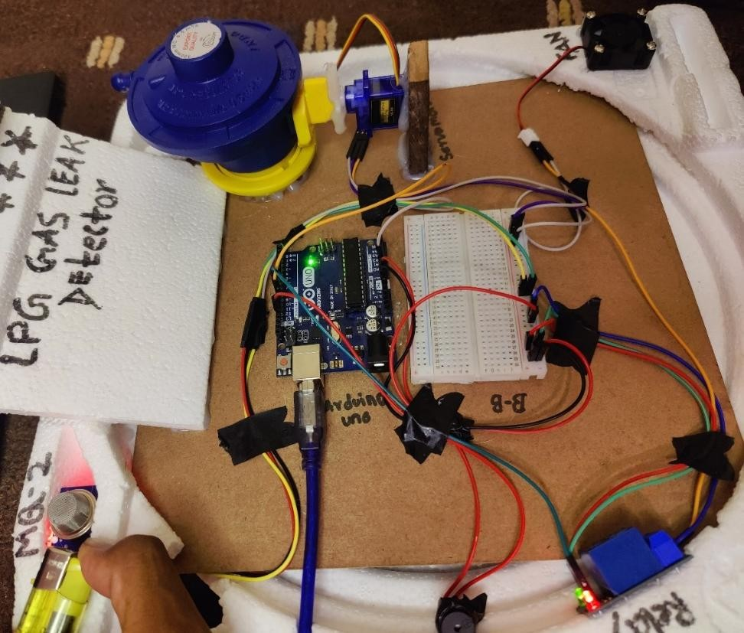

*Figure 25: Screenshot of Test2*

## Test 3: Test if the system reset after gas dissipates

|  |  |
| --- | --- |
| Objectives | To verify that the system returns to normal once the gas is cleared. |
| Activity | Removing the gas source and ventilate area. Monitoring sensor values and components state |
| Expected Result | Senor value drops below the threshold and buzzer turns off |
| Actual Result | Sensor returned to its idle state after gas cleared |
| Conclusion | The test is successful. |

*Table 4: Table of Test3*

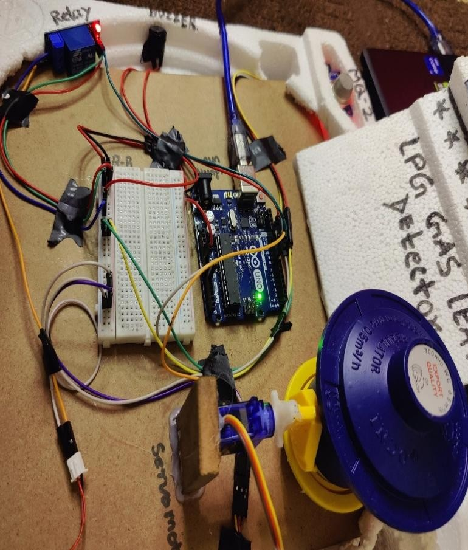

*Figure 26: Screenshot of Test3*

## Test 4: Test if system avoids false positives

|  |  |
| --- | --- |
| Objectives | To test the sensor does not falsely trigger on non-gaseous element |
| Activity | Exposing the sensor to other triggers like air freshener and monitor behavior. |
| Expected Result | System should not activate unless LPG or similar gas is present |
| Actual Result | Sensor did not trigger falsely in the presence of air freshener |
| Conclusion | The test is successful. |

*Table 5: Table of Test4*

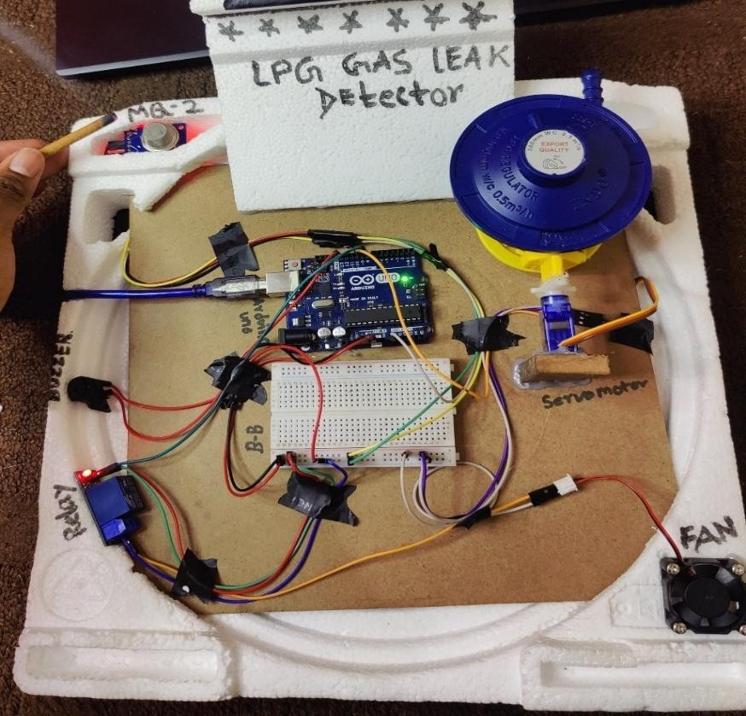

*Figure 27: Screenshot of Test4*

## Test 5: Test Servo Motor Operation

|  |  |
| --- | --- |
| Objectives | To ensure the servo motor operates correctly to open or close the valve when gas is detected. |
| Activity | Simulate gas detection and observe if the servo motor rotates to close the valve as intended. |
| Expected Result | Servo motor should rotate to the predefined angle to close the valve upon gas detection. |
| Actual Result | Servo motor rotated accurately and closed the valve when gas was detected. |
| Conclusion | The test is successful. |

*Table 6: Table of Test5*

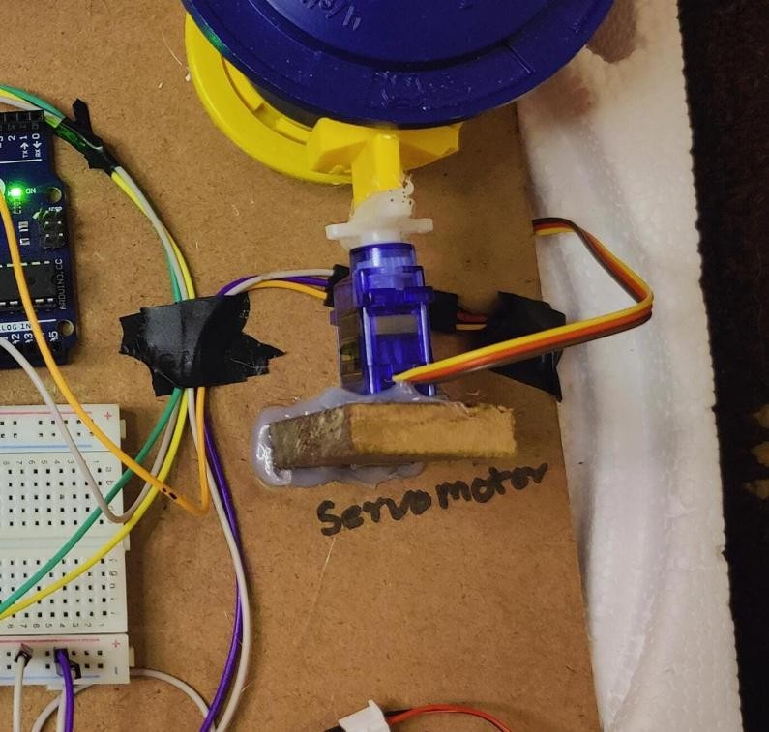

*Figure 28: Screenshot of servo before Test5*

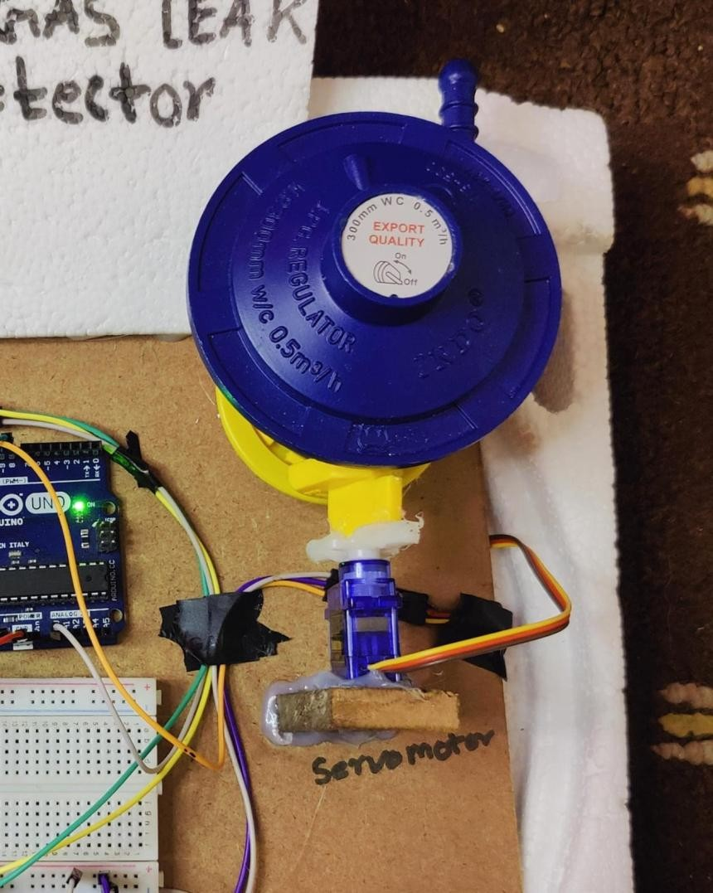

*Figure 29: Screenshot of servo after Test5*

# 5 Future Works

## 5.1 Enhanced Gas Detection Technology

* Better Sensors: Precise detection of minimal LPG concentrations requires using advanced gas sensors which include NDIR (Non-Dispersive Infrared) sensors because of their enhanced sensitivity and specificity.
* Multi-Gas Detection: The system should reach higher safety standards by adding capabilities to detect hydrogen and carbon monoxide gas alongside methane.

## 5.2 Improved Automation Tools

* Smart Regulator Control: During use the system must automatically alter or shut off the regulator through AI algorithms when AI detection indicates possible gas leakage.
* Self-Diagnostics: An automatic performance evaluation system for sensor and actuator performance should be implemented to ensure long-term reliability.

## 5.3 IoT Integration

* Remote Monitoring: During gas leak situations your system can deliver automatic warnings to mobile phones either through messaging services or smartphone applications with built-in GSM and Wi-Fi components.
* Cloud Data Logging: The system enables users to inspect and predict petrol consumption patterns by maintaining data in cloud storage for analysts to investigate historical trends.

## 5.4 Energy Efficiency and Backup

* Energy-Saving Mode: The system activates sensors for monitoring purposes only when movement occurs within proximity to the gas source for power optimization.
* Battery Backup: Power supply protection during outages can be achieved by adding solar panels or establishing a rechargeable battery system.

## 5.5 Safety Features

* Voice Alerts: Voice-controlled alerts installed in the house improve accessibility for visually-impaired people through audible notifications of gas leak emergencies.
* Fail-Safe Mechanism: A redundancy system should be installed to shut off gas supply automatically whenever any system component fails.

# 7. Appendix

## 7.1 Source code

#include <Servo.h>

// Define pin numbers const int gasSensorPin = A0; // MQ-2 gas sensor analog pin const int buzzerPin = 13; // Buzzer pin const int servoPin = 9; // Servo motor pin const int relayPin = 8; // Relay pin to control the fan

Servo myServo; // Servo motor object // Threshold for gas detection const int threshold = 300; // Adjust based on calibration

void setup() { // Initialize the pins

pinMode(buzzerPin, OUTPUT); // Set buzzer as output pinMode(relayPin, OUTPUT); // Set relay pin as output

// Attach servo to pin 9 myServo.attach(servoPin);

// Ensure the relay (fan) is initially off digitalWrite(relayPin, HIGH); // Set relay to HIGH to keep the fan off initially

// Start the serial communication for debugging

Serial.begin(9600);

Serial.println("LPG Gas Detection System Initialized");

// Move servo to initial position (Gas regulator ON) myServo.write(0); // Servo in "on" position (0 degrees) }

void loop() {

// Read the gas sensor value int gasValue = analogRead(gasSensorPin);

// Print sensor value to the serial monitor for debugging

Serial.print("Gas Sensor Value: ");

Serial.println(gasValue);

// Check if gas concentration exceeds the threshold if (gasValue > threshold) {

// If gas is detected, activate the buzzer, fan, and servo digitalWrite(relayPin, HIGH); // Turn on the fan (relay)

myServo.write(120); // Move servo to 90 degrees (off position, gas regulator

OFF)

Serial.println("Gas detected! Activating buzzer and fan.");

// danger siren sound pattern for (int i = 0; i < 3; i++) { // Repeat siren effect 3 times (or adjust the number of repetitions)

// Rise in pitch (low to high frequency) for (int freq = 500; freq <= 1500; freq += 20) { // Gradually increase the frequency tone(buzzerPin, freq); delay(10); // Small delay for smooth transition

}

// Fall in pitch (high to low frequency) for (int freq = 1500; freq >= 500; freq -= 20) { // Gradually decrease the frequency

tone(buzzerPin, freq); delay(10); // Small delay for smooth transition

}

}

} else {

// If no gas is detected, deactivate the buzzer, fan, and reset servo digitalWrite(relayPin, LOW); // Turn off the fan (relay) myServo.write(0); // Reset servo to 0 degrees (on position, gas regulator ON)

Serial.println("No gas detected. System idle.");

// Stop any sound from buzzer if gas is not detected noTone(buzzerPin);

}

delay(1000); // Delay for 1 second before the next reading

}